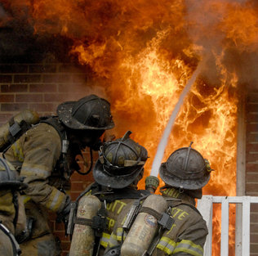
Charlotte Fire Department
FY12-13 Strategic Operating Plan

Jon B. Hannan, Fire Chief
Jeffrey M. Dulin, Deputy Fire Chief
Richard O. Granger, Jr., Deputy Fire Chief
Howard (Pete) Key, Deputy Fire Chief
Robert D. Kinniburgh, III, Deputy Fire Chief

Table of Contents

- Executive Summary 4
Transmittal Letter
Introduction
Summary of Resource Needs
Vision and Mission
Key Issues and Challenges
Organization Chart

- Strategy and Planning 8
Accomplishments
Links to Corporate Strategy
Strategic Initiatives

- Service Delivery 11
Service Delivery
Services
Service History and Trends

- Balanced Scorecard and Performance Measures 19

- Resource Allocation Summary 22

- Appendices 26
A. KBU Link to Corporate Scorecard B. Measure Validation Forms

I. Executive Summary

Introduction

True to our mission, the Charlotte Fire Department’s primary functions revolve around preserving life and property through rapid emergency response, code enforcement, education and planning.

Emergency Response has been the Department's primary reason for existence since 1887. Services include but are not limited to fire suppression, first responder emergency medical services, hazardous materials mitigation, technical rescue, dive rescue and aircraft rescue firefighting.

The Fire Prevention Bureau focuses on preventing and investigating emergencies, fire code enforcement, plans review, hazardous materials permitting, fire and accident prevention education, fire investigation, and arson prevention.

Emergency Management ensures that City and County government maintain a high level of preparedness. They work to ensure that potential situations involving homeland security, terrorism, or other disasters can be quickly mitigated.

Summary of Resources

 | FY10  Actual | FY11 Revised Budget | FY12 Budget Request | FY13 Budget Request
Budget | 96,725,010 | 97,907,480 | 104,874,898 | 105,907,010
Positions | 1144 | 1,165 | 1,166 | 1,166

Vision and Mission

Vision: Continue to meet the demand for efficient and effective emergency service delivery with allotted resources, while demonstrating a spirit of cooperation and collaboration within the City of Charlotte and the Fire Service.

Mission: To preserve life and property through rapid emergency response, code enforcement, education and planning.

Charlotte Fire Department Organization Chart

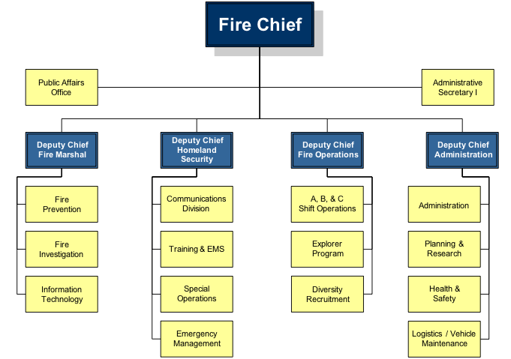

Summary of Resource Needs

While we understand the physical constraints of the budget and the context of the times, we must still work to maintain established service delivery standards.

- Reviewing structural challenges within our budget to address historical over-runs in accounts such as fuel, apparatus maintenance, utilities, janitorial supplies, and training lines.
- Identify funding sources and address end-of-life cycle replacement for the fleet.

II. Strategy and Planning

Key Accomplishments

- Collaborating with CMPD to create a consolidated, co-located Communications Center is a major accomplishment. This project gained significant momentum toward the end of FY11 as land was purchased through funding from the NC911 Board. The impact of this joint venture will be realized by CMPD, CFD and the citizens of Charlotte.

- Meeting response time benchmarks. These are a key strategic performance indicator for our department. Much of what we do as a department is driven by this target. Our goal is for first-due fire companies to arrive on scene within 6 minutes of the phone call being answered by a Fire Telecommunicator, at least 80 percent of the time. In FY10, met this target 80.23% of the time with an average response time of 4:51. This is significant for several reasons, travel time due to traffic, road humps, distance in many cases has increased. That shows that the CAD, turnout time, dispatch time and many other factors that are in our control have been improved to meet our target.

- Saving lives through the Focused CPR, our collaboration with MEDIC. Defined roles and tasks prior to arrival of all medical personnel responding to the scene, use of the King airway by CFD, uninterrupted CPR by CFD, and intraosseous IV infusion of chilled saline by MEDIC in the pre-hospital setting have combined to produce some impressive survival data. While the data is still preliminary and fluctuates monthly, it shows:

  - a return of spontaneous circulation (ROSC) on greater than 70% specific to patients with Ventricular-Fibrillation / Ventricular Tachycardia arrest (this represents a significant improvement over standard protocols which resulted in a ROSC rate of less than 20%);
  - half of these patients showed no significant neurological deficits;

- Achieving Reaccreditation status from the Commission on Fire Accreditation International. First accredited in 2000, this most recent process caused the Department to review our Standards of Coverage for the City, update our Standard Operating Plan, and improve and update documentation for many of our daily processes.

- Implementation of the Chief Officer Development and Company Officer Development Courses as part of the curriculum for Officer Candidate School(s) I and II.

- Secured funding from the Aviation Department for the full-time Battalion Chief position assigned to the Airport. This position has proven essential in our collaboration with Aviation in managing the resources assigned at Stations 17, 30 and 41.

- Revision of internal business processes by the Fire Prevention Bureau. This resulted in increased efficiency and citizen focus.

Links to Corporate Strategy

All the Charlotte Fire Department’s services fall within the City’s Corporate Strategy. Our links to the Balanced Scorecard are attached as Appendix A, and our services and their links to the corporate strategy are summarized as follows:

Serve the customer. The Charlotte Fire Department provides the emergency services of fire suppression, first responder emergency medical response, technical rescue, dive rescue, swiftwater rescue, hazardous materials mitigation, and aircraft rescue firefighting. Essential public safety services include emergency management, fire code enforcement, hazardous materials permitting, fire, life safety, and accident prevention education, and fire investigation. The intent of all services is to improve public safety by preventing emergencies and minimizing damage to life and property when an incident occurs.

Run the business. The Charlotte Fire Department is a general fund agency; the only revenues come from hazardous materials permitting and plans review fees, which support the Fire Prevention Bureau. Thus, accurate budgeting and monitoring of expenditures is essential to the fiscal health of the organization, to ensure that emergency and public safety services are provided.

Manage resources. Effective emergency services depend on having an adequate number of personnel resources when and where they are needed. The Fire Department is fortunate that the City has always chosen to staff fire companies to the level recognized as necessary for effective response to emergencies. For effective emergency services, the Department needs minimum staffing of 255 firefighters and officers on duty at all times (365/24/7). The Battalion Chiefs are responsible for ensuring that staffing requirements are met.

Develop employees. Delivery of the Fire Department services is predicated on employees obtaining and maintaining the relevant State certifications for the positions they hold. The Training Division is responsible for ensuring that firefighters maintain required emergency service certifications; fire inspectors, telecommunicators, and fire investigators must also complete training in their respective areas to meet professional standards. Educational reimbursement is thoroughly ingrained in our culture. Many of our employees take advantage of this benefit to prepare for the future by earning degrees.

Strategic Initiatives

Educate and prepare children to prevent injuries and fires and teach them how to respond appropriately when they do occur. (Strengthen neighborhood corporate objectives)

- Eighty percent of all third grade classrooms will receive fire education programs.

Provide emergency services (Increase perception of safety corporate objective)

- Telecommunicators will answer 90 percent of phone calls within 10 seconds.

- First-due fire companies will be on-scene to 80 percent of all emergencies within 6 minutes of phone notification.

- A first alarm assignment will be on-scene at 80 percent of all first alarm emergencies within 9 minutes of phone notification.

Provide effective public safety services (Increase perception of safety corporate objective)

- Inspectors will inspect 95 percent of non-residential properties within the frequencies mandated by the North Carolina Fire Code.

- Investigators will clear 36 percent of arson cases, which is twice as many as the national average of 18 percent.

Provide training opportunities (Increase perception of safety corporate objective)

- Five All Hazards Incident Command System Training Courses will be held in the Charlotte UASI, and will be open to our regional UASI partners.

Provide useful management information (Optimize business processes corporate objective)

- Consolidate the Fire and Police Computer Aided Dispatch (CAD) Systems by June 30, 2012.

Monitor budget expenditures (Deliver competitive service corporate objective)

- 10 percent of the department’s discretionary purchases will be made with certified SBE’s.

Maintain optimal staffing and fire company availability (Deliver competitive service corporate objective)

- Ensure minimum staffing of 255 firefighters and officers on duty daily 95 percent of the time.

- Fire companies will be available to respond to calls 80 percent of the time during business hours (8 a.m. – 6 p.m. Monday – Friday).

Maintain certifications (Recruit and retain skilled, diverse workforce corporate objective)

- Ninety-eight percent of firefighters will maintain EMT certification.

- Female and minorities will make up 25 percent of the firefighter applicant pool.

Support physical fitness (Wellness objective)

- Set a goal that at least 95 percent of fire operations staff will participate in annual fitness evaluations.

- Prepare a wellness message for inclusion in the department’s monthly newsletters. This goal will be met 100 percent of the time.
III. Service Delivery

Service Delivery

This section summarizes the Charlotte Fire Department’s history and the development of services over the years.

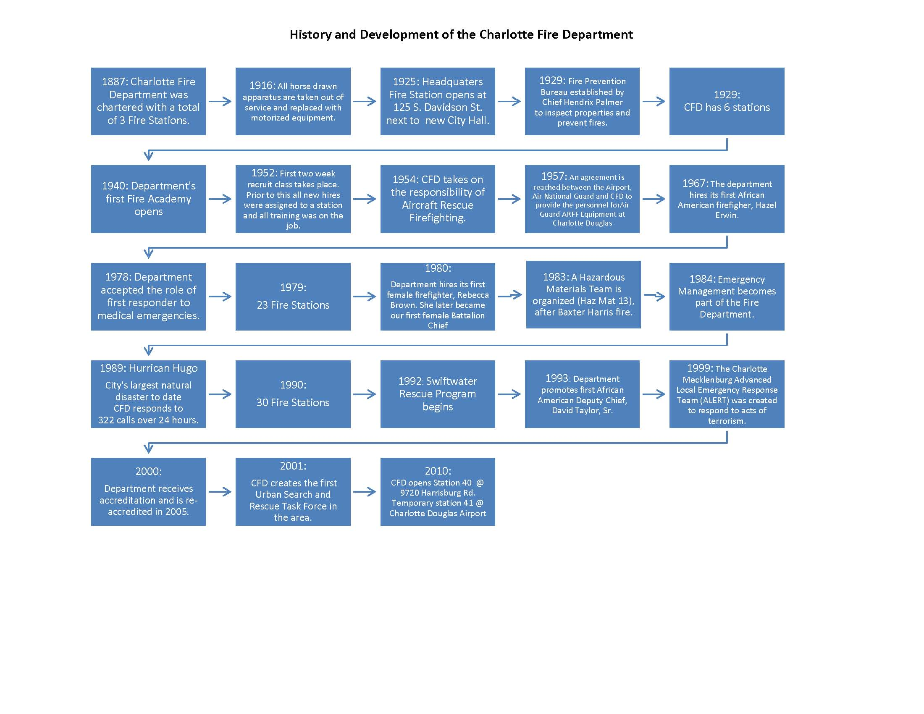

Core Service Areas

The Charlotte Fire Department’s services fall into three core areas:

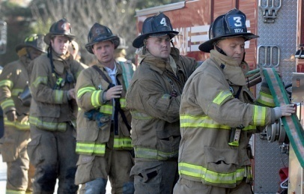
Emergency services: Firefighters provide response to fires, medical emergencies, hazardous materials incidents, rescue incidents, and other emergencies 24 hours a day, seven days a week from 41 fire stations to anyone in the corporate limits who calls with a need.

Fire Prevention Activities: Fire inspectors collaborate with businesses to ensure that provisions of the North Carolina fire code are met, to prevent fires and other emergencies from occurring. Fire and life safety educators work with schools and other groups to bring essential safety messages to children and other vulnerable populations, to prevent injuries and deaths.

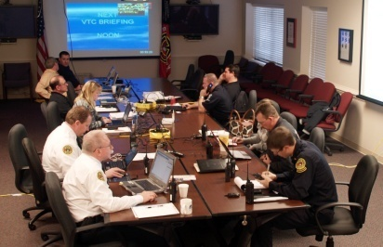
Preparedness: Emergency Management is responsible for ensuring that City and County departments are ready to respond quickly and effectively to any incident, natural or man-made, that disrupts the normal lives of citizens and to provide the services needed to return to normal life.

Service History and Trends

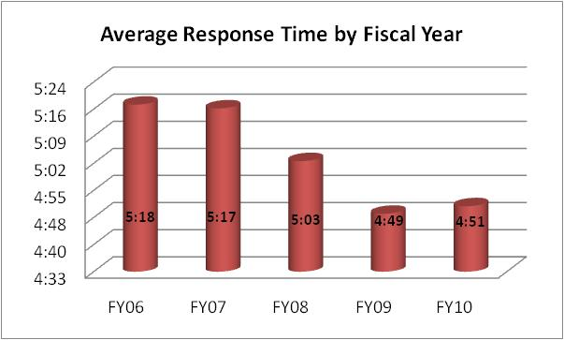

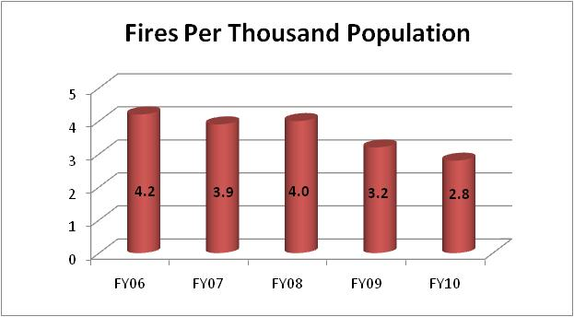

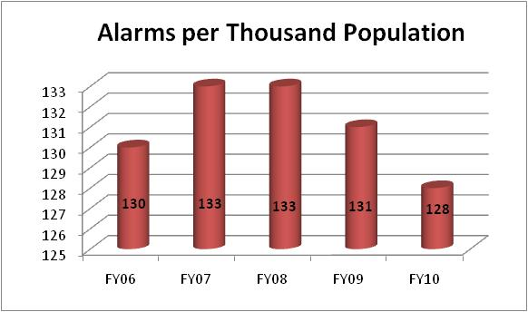

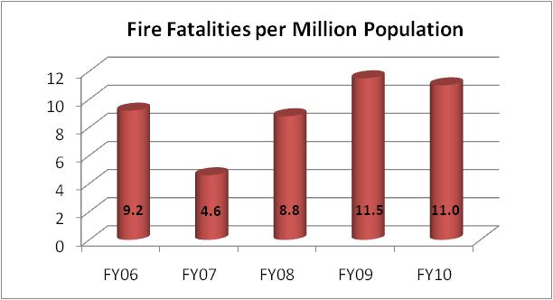

IV. Balanced Scorecard

The Balanced Scorecard helps translate an organization's mission, vision and strategy into tangible objectives. It focuses on four critical success indicators: serve the customer, manage resources, run the business and develop employees. The City of Charlotte uses the Balanced Scorecard as its performance management system.

The key indicators to the success of the Fire Department’s efforts are measured in our KBU Balanced Scorecard. Fire’s Balanced Scorecard Report is displayed over the next two pages. Some examples of our key indicators include the following measures:

- Percent of alarms first-due fire companies will be on scene within six minutes of telephone notification of emergency;
- Percent of alarms effective firefighting force will be on scene within nine minutes of telephone notification of emergency;
- Percent of fire code inspections conducted within state-mandated frequencies.

Serve the Customer | C1.  Strengthen Neighbor-hoods | Strengthen and prepare the community | Percent of CMS 3rd grade classrooms that receive fire education programs $ | N/A | Lag | 80%
 | C2.  Increase Perception of Safety | Provide emergency services (fire suppression, hazmat, etc.) | Percent of Telecommunicators answering phone within 10 seconds | 99.1% | Lag | 90%
 |  |  | Percent of alarms first fire company will be on scene within 6 minutes of telephone call* | 81.1% | Lag | 80%
 |  |  | Percent of first alarm fires to which an effective firefighting force will be on scene within 9 minutes | 85.4% | Lag | 80%
 |  | Provide effective public safety services (code enforcement) | Percent of fire code inspections conducted within state-mandated frequencies* | 88.4% | Lag | 95%
 |  | Provide effective public safety services (fire investigation) | Percent of arson cases investigators will clear* | 35.5% | Lag | 36%
 |  | Provide training opportunities | Number of All Hazards Incident Command System Training Courses offered in Charlotte UASI Region* | - | Lag | 5
Run the Business | B1.  Optimize Business Processes | Provide up-to-date systems to support emergency and essential public safety service delivery | Consolidate the Fire and Police Computer Aided Dispatch (CAD) Systems by June 30, 2012* | N/A | Lag | 100%
Manage Resources | R1.  Deliver Competitive Service | Monitor budget expenditures to ensure they are within budget appropriations | Percent of discretionary funds spent with certified SBE’s | N/A | Lag | 15%
 |  | Maintain optimal staffing requirements | Percent of time minimum staff of 255 on fire companies will be maintained $ | 100% | Lag | 95%
 |  | Maintain resource availability | Percent of fire companies in service during daylight hours Monday-Friday $ | 87.1% | Lag | 80%
Develop Employees | E1.  Recruit and Retain Skilled, Diverse Workforce | Maintain certifications | Number of active firefighters that will maintain EMT certification | 100% | Lag | 98%
 |  | Promote a diverse workforce | Percent of women and minorities in firefighter applicant pool* | - | Lag | 25%
 | E2. Achieve Positive Employee Climate | Support physical fitness | Number of firefighters who participate in annual fitness evaluations $ | N/A | Lag | 95%
 |  |  | Distribute wellness message in department newsletter $ | N/A | Lag | 100%

